**Deploying our first component**

The sample application is composed of a set of Kubernetes manifests organized in a way that can be easily applied with Kustomize. Kustomize is an open-source tool also provided as a native feature of the kubectl CLI. This workshop uses Kustomize to apply changes to Kubernetes manifests, making it easier to understand changes to manifest files without needing to manually edit YAML. As we work through the various modules of this workshop, we'll incrementally apply overlays and patches with Kustomize.

The easiest way to browse the YAML manifests for the sample application and the modules in this workshop is using the file browser in Cloud9:

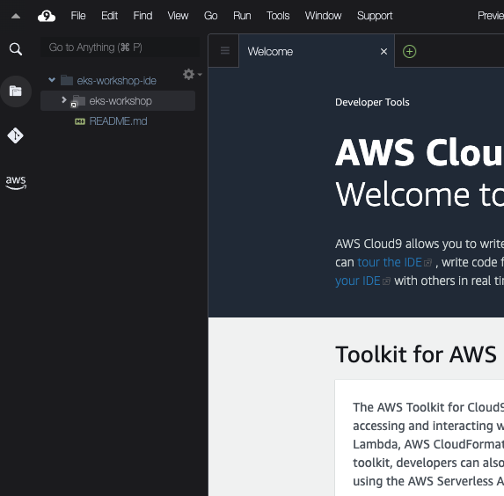

Expanding the eks-workshop and then base-application items will allow you to browse the manifests that make up the initial state of the sample application:

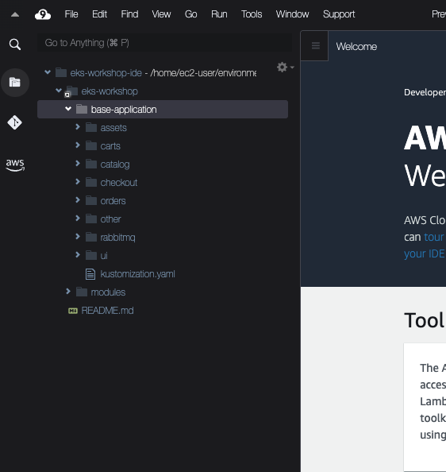

The structure consists of a directory for each application component that was outlined in the **Sample application** section.

The modules directory contains sets of manifests that we will apply to the cluster throughout the subsequent lab exercises:

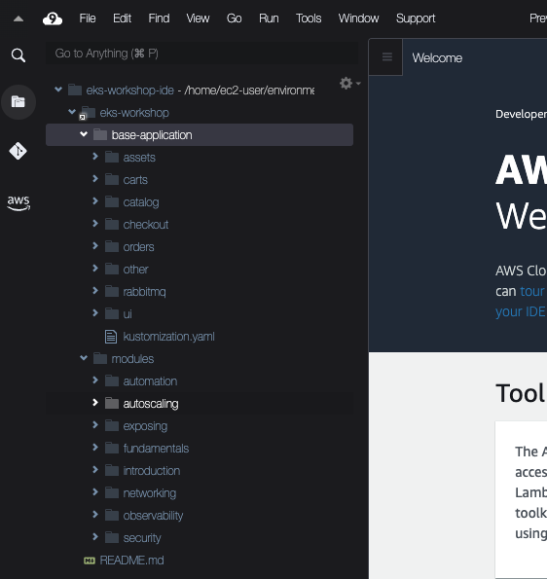

Before we do anything lets inspect the current Namespaces in our EKS cluster:

~$kubectl get namespaces

NAME STATUS AGE

default Active 1h

kube-node-lease Active 1h

kube-public Active 1h

kube-system Active 1h

All of the entries listed are Namespaces for system components that were pre-installed for us. We'll ignore these by using [Kubernetes labels](https://kubernetes.io/docs/concepts/overview/working-with-objects/labels/) to filter the Namespaces down to only those we've created:

~$kubectl get namespaces -l app.kubernetes.io/created-by=eks-workshop

No resources found

The first thing we'll do is deploy the catalog component by itself. The manifests for this component can be found in ~/environment/eks-workshop/base-application/catalog.

~$ls ~/environment/eks-workshop/base-application/catalog

configMap.yaml

deployment.yaml

kustomization.yaml

namespace.yaml

secrets.yaml

service-mysql.yaml

service.yaml

serviceAccount.yaml

statefulset-mysql.yaml

These manifests include the Deployment for the catalog API:

~/environment/eks-workshop/base-application/catalog/deployment.yaml

apiVersion: apps/v1  
kind: Deployment  
metadata:  
 name: catalog  
 labels:  
 app.kubernetes.io/created-by: eks-workshop  
 app.kubernetes.io/type: app  
spec:  
 replicas: 1  
 selector:  
 matchLabels:  
 app.kubernetes.io/name: catalog  
 app.kubernetes.io/instance: catalog  
 app.kubernetes.io/component: service  
 template:  
 metadata:  
 annotations:  
 prometheus.io/path: /metrics  
 prometheus.io/port: "8080"  
 prometheus.io/scrape: "true"  
 labels:  
 app.kubernetes.io/name: catalog  
 app.kubernetes.io/instance: catalog  
 app.kubernetes.io/component: service  
 app.kubernetes.io/created-by: eks-workshop  
 spec:  
 serviceAccountName: catalog  
 securityContext:  
 fsGroup: 1000  
 containers:  
 - name: catalog  
 env:  
 - name: DB\_USER  
 valueFrom:  
 secretKeyRef:  
 name: catalog-db  
 key: username  
 - name: DB\_PASSWORD  
 valueFrom:  
 secretKeyRef:  
 name: catalog-db  
 key: password  
 envFrom:  
 - configMapRef:  
 name: catalog  
 securityContext:  
 capabilities:  
 drop:  
 - ALL  
 readOnlyRootFilesystem: true  
 runAsNonRoot: true  
 runAsUser: 1000  
 image: "public.ecr.aws/aws-containers/retail-store-sample-catalog:0.4.0"  
 imagePullPolicy: IfNotPresent  
 ports:  
 - name: http  
 containerPort: 8080  
 protocol: TCP  
 livenessProbe:  
 httpGet:  
 path: /health  
 port: 8080  
 initialDelaySeconds: 30  
 periodSeconds: 3  
 readinessProbe:  
 httpGet:  
 path: /health  
 port: 8080  
 successThreshold: 3  
 periodSeconds: 5  
 resources:  
 limits:  
 memory: 512Mi  
 requests:  
 cpu: 250m  
 memory: 512Mi  
 volumeMounts:  
 - mountPath: /tmp  
 name: tmp-volume  
 volumes:  
 - name: tmp-volume  
 emptyDir:  
 medium: Memory

This Deployment expresses the desired state of the catalog API component:

* Use the public.ecr.aws/aws-containers/retail-store-sample-catalog container image
* Run a single replica
* Expose the container on port 8080 named http
* Run [probes/healthchecks](https://kubernetes.io/docs/tasks/configure-pod-container/configure-liveness-readiness-startup-probes/) against the /health path
* [Requests](https://kubernetes.io/docs/concepts/configuration/manage-resources-containers/) a specific amount of CPU and memory so the Kubernetes scheduler can place it on a node with enough available resources
* Apply labels to the Pods so other resources can refer to them

The manifests also include the Service used by other components to access the catalog API:

~/environment/eks-workshop/base-application/catalog/service.yaml

apiVersion: v1  
kind: Service  
metadata:  
 name: catalog  
 labels:  
 app.kubernetes.io/created-by: eks-workshop  
spec:  
 type: ClusterIP  
 ports:  
 - port: 80  
 targetPort: http  
 protocol: TCP  
 name: http  
 selector:  
 app.kubernetes.io/name: catalog  
 app.kubernetes.io/instance: catalog  
 app.kubernetes.io/component: service

This Service:

* Selects catalog Pods using labels that match what we expressed in the Deployment above
* Exposes itself on port 80
* Targets the http port exposed by the Deployment, which translates to port 8080

Let's create the catalog component:

~$kubectl apply -k ~/environment/eks-workshop/base-application/catalog

namespace/catalog created

serviceaccount/catalog created

configmap/catalog created

secret/catalog-db created

service/catalog created

service/catalog-mysql created

deployment.apps/catalog created

statefulset.apps/catalog-mysql created

Now we'll see a new Namespace:

~$kubectl get namespaces -l app.kubernetes.io/created-by=eks-workshop

NAME STATUS AGE

catalog Active 15s

We can take a look at the Pods running in this namespace:

~$kubectl get pod -n catalog

NAME READY STATUS RESTARTS AGE

catalog-846479dcdd-fznf5 1/1 Running 2 (43s ago) 46s

catalog-mysql-0 1/1 Running 0 46s

Notice we have a Pod for our catalog API and another for the MySQL database. The catalog Pod is showing a status of CrashLoopBackOff. This is because it needs to be able to connect to the catalog-mysql Pod before it will start, and Kubernetes will keep restarting it until this is the case. Luckily we can use [kubectl wait](https://kubernetes.io/docs/reference/generated/kubectl/kubectl-commands" \l "wait" \t "_blank) to monitor specific Pods until they are in a Ready state:

~$kubectl wait --for=condition=Ready pods --all -n catalog --timeout=180s

Now that the Pods are running we can [check their logs](https://kubernetes.io/docs/reference/generated/kubectl/kubectl-commands#logs), for example the catalog API:

TIP

You can ["follow" the kubectl logs output](https://kubernetes.io/docs/reference/kubectl/cheatsheet/) by using the '-f' option with the command. (Use CTRL-C to stop following the output)

~$kubectl logs -n catalog deployment/catalog

Kubernetes also allows us to easily scale the number of catalog Pods horizontally:

~$kubectl scale -n catalog --replicas 3 deployment/catalog

deployment.apps/catalog scaled

~$kubectl wait --for=condition=Ready pods --all -n catalog --timeout=180s

The manifests we applied also create a Service for each of our application and MySQL Pods that can be used by other components in the cluster to connect:

~$kubectl get svc -n catalog

NAME TYPE CLUSTER-IP EXTERNAL-IP PORT(S) AGE

catalog ClusterIP 172.20.83.84 <none> 80/TCP 2m48s

catalog-mysql ClusterIP 172.20.181.252 <none> 3306/TCP 2m48s

These Services are internal to the cluster, so we cannot access them from the Internet or even the VPC. However, we can use [exec](https://kubernetes.io/docs/tasks/debug/debug-application/get-shell-running-container/) to access an existing Pod in the EKS cluster to check the catalog API is working:

~$kubectl -n catalog exec -it \

deployment/catalog -- curl catalog.catalog.svc/catalogue | jq .

You should receive back a JSON payload with product information. Congratulations, you've just deployed your first microservice to Kubernetes with EKS!